

Rye and District Wheelers
Member Newsletter February 2019

From the Chair
Thanks so much to all members who paid their subs so readily and on time, and special thanks to Andrew for the efficient (and diplomatic) way he has conducted this annual exercise. For £15 is there better value for money and friendship available anywhere else on the local sporting scene? I doubt it very much!
A very warm welcome to new members Gary Brown and Chris Bowden. Please feel free to contact any of the Committee members with any questions about the Club or to seek advice about rides and bikes.
And the warmest of welcomes to our new Club Secretary Steve Blattman who was formally elected to the post at the EGM held on 9th February. It is a considerable relief that Steve has taken over the reins so efficiently from Paul Simpson.
As Spring approaches and we no longer need cold weather gear it would be great to see more members wearing Club kit. We have good stock levels and we are about to order more. Please contact Club Captain, Dave Greenwood, if you are in the market for new kit. We will get kit out to members as quickly as possible via Committee members or by making it available for collection once a month at Committee meetings.
Please take note of the dates for Club events notified in this Newsletter. It is so easy to let dates slip from memory so get them in the diary now!
Finally, good luck to Nick Wilson, William Murtagh, James Ashburnham, Dave Greenwood, Steve Gooch and Barry Goodsell - all riding in the Kent Cycling Association 3 Up team event on 3rd March.
Paul Wilson

From the Captain
Late February has brought some decent cycling days, the Tuesday/Friday group has continued to record decent turn outs. On Friday, Dave Hayter kindly planned the route and cafe stop for what looked like a decent ride. This Sunday’s Club ride was better attended with three groups heading to different locations. Red group headed to Whiskeys, Hurst Green for the Black group and the newly named B Black group headed to Hythe. I see Jamie Kirkham recorded a solo ride on Sunday, so hopefully we will see more of him in good time.
A few encouraging Strava facts, last week 22 club members recorded a weekly mileage of 2,200 miles with 67,350 feet of climbing (and that’s just on Strava). So, if you are on Strava but not on the Club page, get yourself on it.
I know of one (well two) spills in February, Leigh Foxton had a minor coming together with a pickup in Tenterden, but happy to say nothing long term and was soon back out riding. The other was me, whilst negotiating a U-turn on the very steeply inclined and very slippery Military Road. So be careful out there.
A timely reminder as we enter March, the first of the Captains rides is on the 17th March, hoping for good weather and a good turn out to match.

David Greenwood

From the Treasurer
Many thanks to everyone for paying their subs so promptly - it has made my job so much easier this year.

We are checking to make sure everyone has received their membership card, so if you haven't received your card in the next couple of weeks please do not hesitate to chase me up!

Don't forget to let us know changes in your personal admin during the year - mobiles, email addresses etc.

Andrew Whittaker

From the Secretary
Well, my first few weeks as secretary for the club and I’m feeling my way with the I.T. side of things! Good handover from Paul Simpson – the website, email, affiliations to other bodies and so on. I’ve done the job before for the Swimming Pool Association but that was before the internet and emails!

I’ve been making the most of the club rides with some recent good weather. The Friday club ride on 21st February was my first trip ride to Wye. A rather miserable start with a heavy fog which meant taking off my glasses as with other riders, a toss-up between a visibility of a few metres or clearer but out of focus view! But, it turned out nice after our stop for some snap followed by a route via Bethersden and Woodchurch back to Rye.

A few dates for your diary which I will probably be banging on about as last year we didn’t have a great turn out mainly due to holidays etc. and of course people do other things than cycling.

- Spring Captain’s Ride – 17th March
- Le Carre de Vallees, Ardres – 2nd June
- Summer Captain’s Ride, Treasure Hunt and BBQ – 30th June
- Up For Lunch – 1st September
- Le Tour De Rye et Romney Marsh – 29th September

Steve Blattman

From the Racing Secretary
Whilst there is little to report at the moment for time trials, William Murtagh, who is back racing in Rye colours, has scored the club’s first win in a road race since the 1950s. In January, he contested a round of East London Velo’s Winter series, and came out on top of a field of twenty-four riders. Since his win, William has been back for another round where he and another rider were able to break away with six laps remaining. On this occasion William finished with an excellent second place, having not been able to contest the victory sprint due to gear change issues. With this finish, William has gained enough points to earn a category 3 racing licence, so I look forward to updating everyone with his seasons progress.

The Kent 2019 time trialling season starts with the 3 up team event on 3rd March and this year the club has three teams entered. Thanks are due, in advance, to both Mark Amon and Mark Wright who have kindly volunteered to marshal. If anyone would like to come and cheer, the first teams set off at 07:30 from the Oasis cafe on the Q25/12 course which goes via the Brenzett, Brookland and Ashford roundabouts, and back to Brenzett to finish.

Nick Wilson

Get to Know . . .Rebecca Wilson
When did you start cycling and when did you join Rye Wheelers?
I started mountain biking in the mid 80s and that’s how I met my husband Nick. We went on an MTB trip for our honeymoon. When our children were young, I didn’t ride much but Nick started road cycling. It was in 2005 that some friends suggested that we should try a time trial and we came along to a Rye club 10. We were signed up, there and then by Jim Hollands.

What motivates you to ride and train?
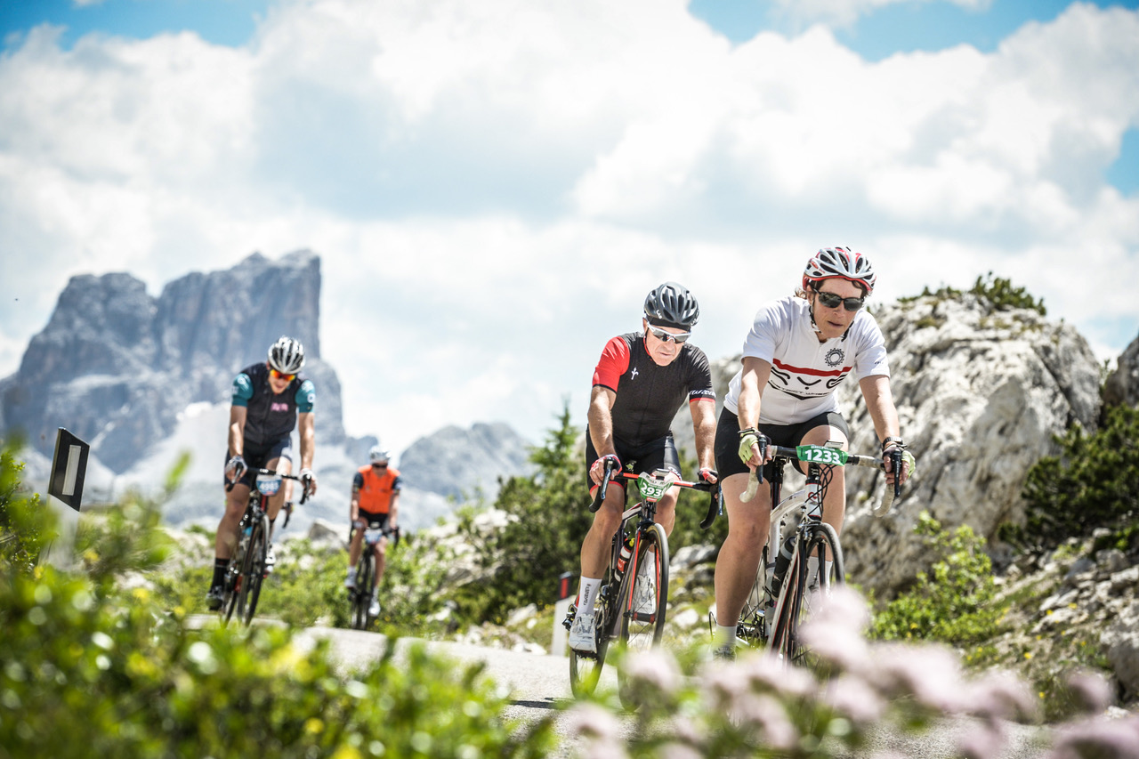
I really enjoy racing, but struggle to motivate myself to train. I wish I had come to TT much earlier in my life, but am realistic about my potential and what is achievable for me with minimal training and age against me. I am, however, competitive by nature and am very determined. I really enjoy the camaraderie and banter within our club and the wider TT community. This year I will ride the Maratona and possibly have another crack at the 24 hour. I have ridden all distances including the 12 and 24 hours, and relish the challenge of the longer events.

Do you have a favourite route and cafe stop?
Because I tend to ride solo, I don’t generally stop. I either do a loop out through Ninfield, because I know how long it takes, or I like to ride out towards Brightling /Burwash because it is so beautiful out that way. The Captain’s rides are great events, and are a good opportunity to catch up with non-racing members.

Tell us more about you and your interests?
Theoretically, I should have plenty of time on my hands now that the children are grown up, but I’m a poor time manager and tend to flit from one thing to another. I love my dog and we go on long walks, I spend my time gardening and watching the birds. I love running and belong to Hastings Athletic Club, I have entered Hastings half marathon for the 11th time and I’m training hard for that at the moment. Once that’s over, I’ll get back to my cycle training - promise!!

Contact Details
Paul Wilson, Chair: stonegarth@gmail.com
Steve Blattman, Secretary: ryewheelers@outlook.com
Andrew Whittaker, Treasurer: andrewwitt500@gmail.com
Dave Greenwood, Club Captain: dmgreenwood65@aol.com
Nick Wilson, Racing Secretary: mail@dotwilson.com

